SGUK NATIONAL
HEALTH AND SAFETY
AWARDS
2022

Innovation Awards
Entry Pack

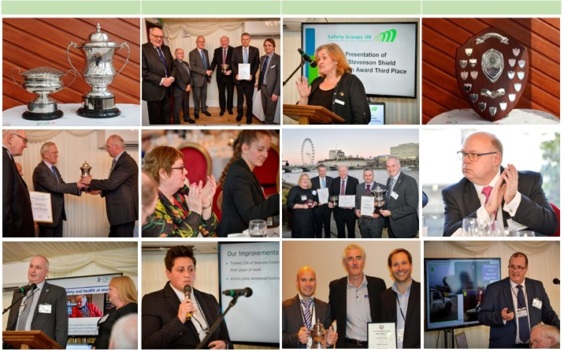
Form 01
SGUK
NATIONAL HEALTH AND SAFETY AWARDS
Innovation Awards 2022

Entry Form

Submission deadline – Friday 29th July 2022

By Email to: safetygroupsuk@rospa.com
Entrants Details
Organisation Name:
Type of organisation:
Specialisms or important features of the Organisation:
Submitted by:
Contact details (1): | Tel: |  | Email:
Contact details (2): | Tel: |  | Email:
Address:
Safety Group Details (if organisation is a current member)
Safety Group Name:
Contact in Safety Group:
Contact details: | Tel: |  | Email:

Please provide a title for your innovation award submission
This will be added to the award certificate provided to winners. This is to certify that the Award has been awarded to XXX for their entry [ 60 characters maximum ]

Please provide a summary description of your innovation award submission
Approximately 250 words

Supporting information
You may provide additional supporting information, please list information provided and explain what it will show the judges

Entries will be evaluated to select those required to make a presentation to the judges.
By submitting an entry for this award we agree to be bound by the SGUK Awards Rules of Entry.

Rules of Entry SGUK Awards

General rules of entry:
- Entries must be submitted by the entry date in the format required by the entry form.
- All entries will be given equal consideration.
- Permission for entries to be shared and copied or adapted Free of Charge by Safety Groups and other organisations is a condition of entry.
- All entries may be used to create interest in the Awards through specialist press and the SGUK website and/or case study material by the HSE, and other partner organisations.
- A panel appointed by the SGUK Board will judge the entries and allocate awards. The decision of the panel will be final.

Rules of entry for Innovation Awards:
- The awards are open to any organisation of any size based or operating in the UK, whether or not they are currently a member of a Safety Group and all Safety Groups in the UK.
- The entry is to be for an activity or physical or systemic in nature (‘project’). It must be relevant, current and innovative. It can be a development of a previous idea, system or item of equipment.
- Entrants must provide a title and describe the purpose of the ‘project’, the method adopted in achieving the outcomes and the health and safety outcomes achieved in terms of improved standards – providing a baseline and evidence of the outcomes.
- Entrants must describe how the ‘project’ contributes to, or compliments, Helping GB Work Well or some other equivalent current UK/national strategy for health and safety improvement, for example, the Scottish Plan for Action on Safety and Health (SPlASH).
- Entrants must provide indicative information on the human and material resources deployed by the organisation itself and, if relevant, other partners (full cost-benefit is not required).
- Entrants must provide testimony from people involved in the delivery of the ‘project’ and from those who benefit from it.
- The innovation must have taken place within 18 months of the date that the award is closed for entries.
- Entrants must be willing to present their entry to the judges during a virtual meeting at a time and date to be advised. The presentation should be no more than 30 minutes.

Guidance on completing the entry form, providing information and the entry process

Entries for the SGUK Innovation Awards are open to organisations of any size who agree to and can fulfil the rules of entry, based or operating in the UK, whether or not they are currently members of a Safety Group, including Safety Groups.

The aim of the awards is to recognise the excellent innovative work being done to raise the standards of health and safety management and to enable those involved to share this success. Our aim is to celebrate and share best practice and the latest thinking and innovation in health and safety management. Many Safety Groups have their own award schemes for good work and innovation, most winning submissions would be eminently suitable as entries for the SGUK Innovation awards and would usually pass the initial, relevance screening process.

Please remember that you are completing an entry form to enable the judges to analyse your entry to decide who will be asked to make a further presentation to the judges and to decide an overall winner of the Innovation Awards. How you complete the entry form should assist this process. You should avoid combining different innovative work in one entry, this can inhibit the judges’ view of the submission. It is better to make more than one clear and specific entry or decide which aspect is the best and submit an entry based on this.

One of the important aspects of the process is that you need to communicate to the judges the relevance and innovation related to your entry in the summary description. This means that if you are going to do this well you will need to carefully explain how you have met the criteria set out in the rules of entry.

Where possible, please use a maximum of 250 words to provide a summary description of your entry. Make every word count. This is sometimes best done by drafting the answer and another person who was not involved reading it to see how well your answer communicates what you intended. If no one else is available, put your entry form away for a few days and then come back and read it, you may then be able to see how it could be clearer or more convincing.

Your entry form may need to be supported by additional information. Additional information should be sufficient for the judges to understand your entry and provide confirmation of what you are stating. You will need to list the additional information and explain what it will show the judges. For example, if you have included a copy of a training programme related to your entry explain why. If your training programme is used to illustrate how you brought about the changes and outcomes in an innovative way, explain this in your list. If you want the judges to understand how this was innovative explain this in your description.

Additional information is best provided in a form that is referenced, there is not just one way to do this, but the judges will find it easier to understand your entry if they can quickly identify the additional information you are referring to.

Your entry form and additional information is usually printed and prepared for the judges in a pack that can be easily considered by a number of judges on the day of the judging. However, depending on circumstances the judging may take remotely. In each case the judges do have access to a computer and the internet at the time of judging so your evidence can be in electronic form.

The initial entry is evaluated by the judges to determine which entries they wish to see presented to them in more detail and to enable further questions to be asked by the judges to determine the innovation and relevance of the entry. This presentation can be made in person on a date to be specified or an active electronic presentation method, for example Skype, may be used to make the presentation on the day.

The judging panel will assess all entries against the following elements: | Evidence from each element will be used to assess the entry under the following four main criteria:
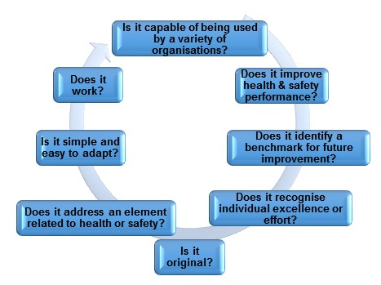 | 